Review for final exam
Part 1: Induction and Recurrence
- Induction proof
Ex: Prove that
$$1+2^{3}+3^{3}+…+ n^{3}= \frac{n^{2}(n+1)}{4}$$
- Solve recurrence relation
Example 1:
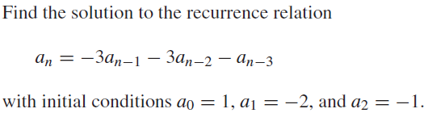

Example 2:
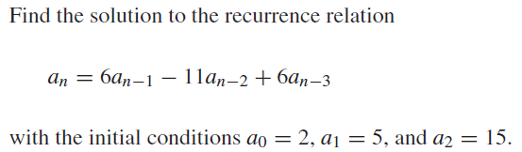
Example 3:
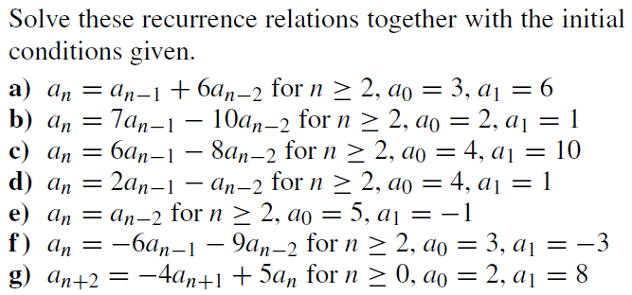

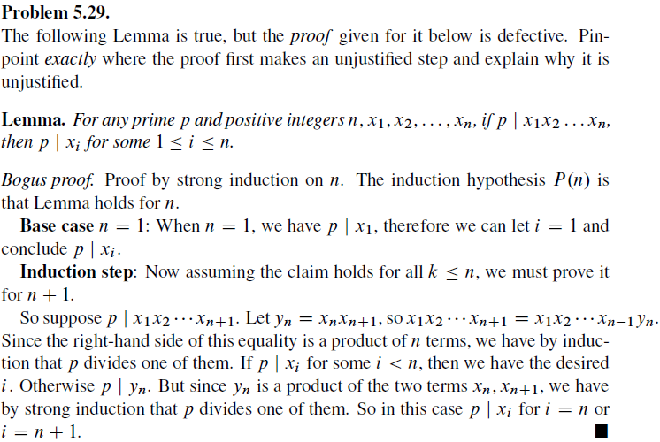
Part 2: Relation
- Determine if a relation is an equivalence or order relation
- Construct Hasse diagram, find maximal/minimal, the greatest/ smallest elements in a poset.
Part 3: Graph
- Euler path
- Dijkstra algorithm to find the shortest path.

